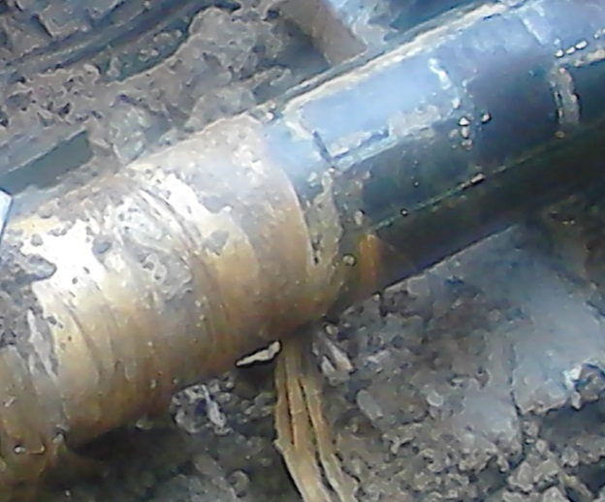 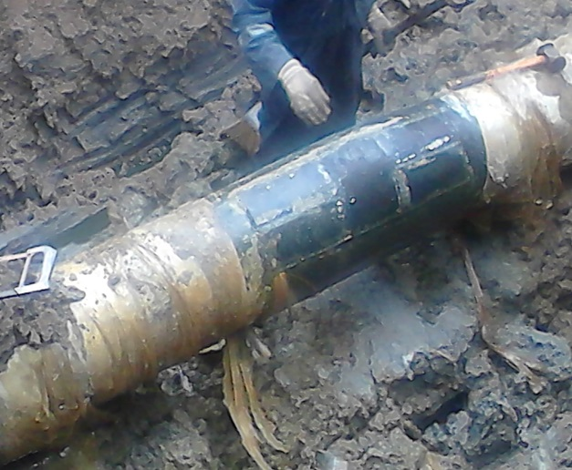 Fig. 1a Pin Hole on a failed Welded Point Fig.1b @ 9 - 10 O’clock Position
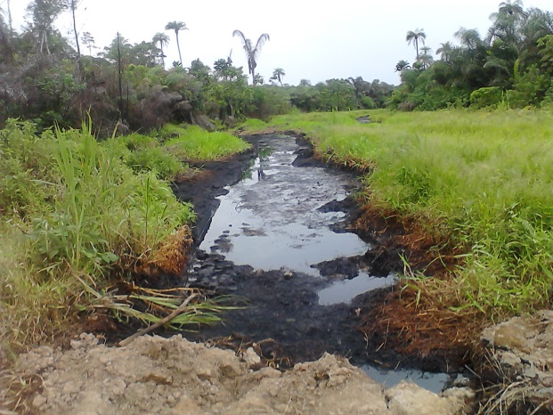 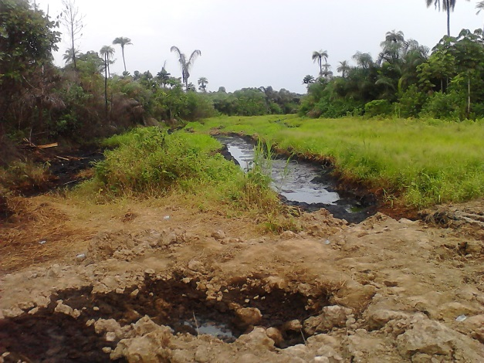 Fig. 2a ROW Heavily Saturated with Crude Oil Fig. 2b Adjourning Environ. Saturated
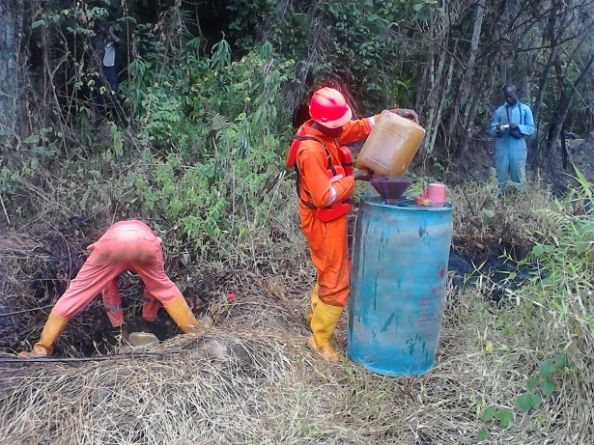 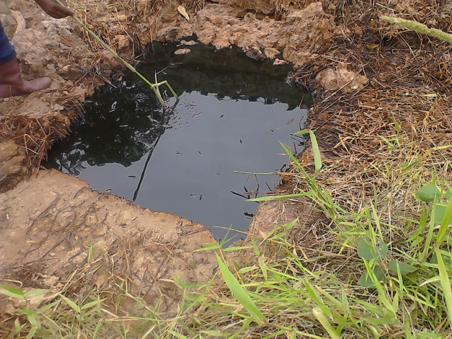 Fig. 3a Crude confined within ROW Fig. 3b Contained Crude within ROW
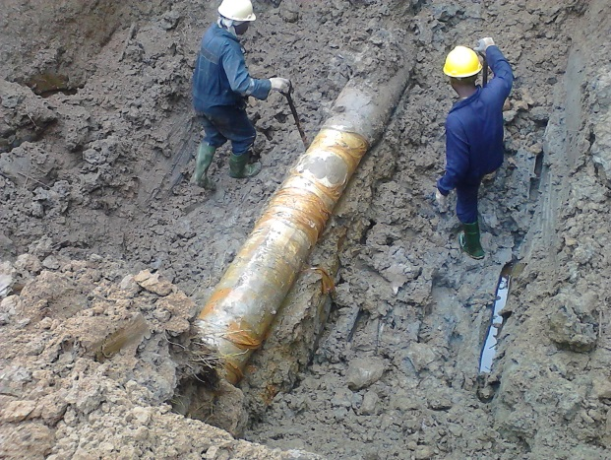 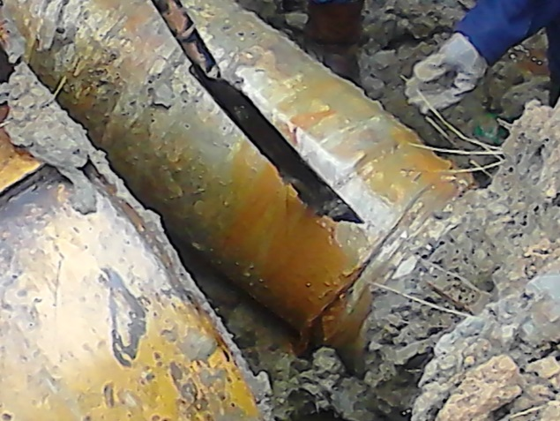 Fig. 4a 14’’ Pipeline in Aqua Wrap Fig. 4b Aqua Wrap intact

